



INTEGRATED OFFICE APPLICATIONS
(215)

STATE 2024

PRODUCTION
Job 1: Table of Contents __________ (100 points)
Job 2: Database __________ (200 points)
Job 3: Spreadsheet __________ (100 points)
Job 4: Memorandum __________ (100 points)
TOTAL POINTS __________ (500 points)

Test Time: 90 minutes

GENERAL GUIDELINES:
Failure to adhere to any of the following rules will result in disqualification:
- Member must hand in this test booklet and all printouts if any.
- No equipment, supplies, or materials other than those specified for this event are allowed in the testing area. No previous BPA tests and/or sample tests (handwritten, photocopied, or keyed) are allowed in the testing area.
- Electronic devices will be monitored according to ACT standards.

EXAM GUIDELINES:
- Ensure this test booklet contains Jobs 1-4.
- Key all jobs according to the instructions given.
- Correct any and all formatting, spelling or grammar errors. Use the formatting guide in the Style & Reference Manual.
- Your name or initials should not appear on any work you submit. Use your Member ID on any occasion you would normally key your reference initials.
- In the lower right-hand corner of ALL work submitted (unless otherwise specified), key your Member ID and job number.
- If you complete the event before the end of the time allotted, notify the proctor. Time may be considered a factor in determining a winner when there is a tie score.
- Place your scoring sheet on top of your jobs. Jobs should be placed in numerical order.

PRODUCTION STANDARDS
0 Errors | 100 Points
1 Error | 90 Points
2 Errors | 70 Points
3 Errors | 50 Points
4+ Errors | 0 Points

Job 1 – Table of Contents | Possible Points | Points  Awarded
Data input correctly (follows production standards)  0 errors – 100 points, 1 error – 90 points, 2 errors – 70 points, 3 errors – 50 points, 4+ errors – 0 points | 100
Job 1 Total | 100
Job 2 – Database Table
Data input correctly (follows production standards) 0 errors – 50 points, 1 error – 45 points, 2 errors – 35 points, 3 errors – 25 points, 4+ errors – 0 points | 50
Field Types Correct (3 pts each) | 24
Job 2 Member # (name of table), printed, landscape, all 1 page, no truncation | 16
Job 2 Table#1 Total | 100
Job 2A – Database Table
Data input correctly (follows production standards) 0 errors – 25 points, 1 error – 22 points, 2 errors – 17 points, 3 errors – 12 points, 4+ errors – 0 points | 25
Job 2A Member # (name of table), printed, portrait, no truncation | 5
Job 2A Table Total | 30
Job 2B – Relationship
Relationship is a one-to-one, Relationship Report printed | 20
Job 2B Relationship Report Total | 20
Job 2C – Query
LName, FName, Title, Department, New Employee, Phone Number, SS#, Base Pay, Department Head fields included in order | 20
Bonus field created at end, calculated correctly, & formatted as currency | 20
Print in landscape, normal margins | 10
Job 2C Query Total | 50
Job 2 Total | 200
Job 3 – Spreadsheet
Autofit all columns to contents, bold titles, Base Pay Column Accounting with 0 decimals | 10
Hide columns E, F, G, and I | 5
L1 Moving Allowance heading, formula is correct, Accounting 2 decimals | 10
M1 Total Base Pay adding Base Pay, Bonus, and Moving Allowance. Accounting 2 decimals. | 5
N1 Projected Taxes calculated at 25% of Total Base Pay. Accounting 2 decimals. | 10
O1 Net Pay, calculated correctly for each employee. Accounting 2 decimals | 10
New column inserted called Full Name that combines LName and FName | 5
Created a clustered bar chart using Full Name and Net Pay, resize chart to cover A1:O32, title New Employees, add data labels outside end | 15
Print spreadsheet/chart, landscape, fit to one page, Job # Member # in right footer | 10
Print w/formulas | 10
Job 3 Total | 100
Job 4 – Memorandum
Data input correctly (follows production standards)  0 errors – 50 points, 1 error – 45 points, 2 errors – 35 points, 3 errors – 25 points, 4+ errors – 0 points | 50
All merged fields are in the correct spot | 20
Printout with Merged Codes | 20
Printout of Alexandre Dominquez memo | 10
Job 4 Total | 100
TOTAL | 500

JOB 1: Table of Contents. [Note to Grader: 2” top margin, 1” side margins. Refer to the Style & Reference Manual for formatting guidelines.]

TABLE OF CONTENTS

PREFACE ii

ALPHABETICAL LIST iv

- COMPANY INFORMATION

Company Organizational Chart 2
Department Heads 3
Departments 3
Positions 4

- PAY SCHEDULES

By Department 5
By Education 6

- BENEFITS

Health Insurance 8
Life Insurance 9
Long-Term Disability 10
Dental Insurance 11
Vision Insurance 12

- LEAVES

Sick 14
Vacation 14
Funeral 15
FMLA 16

APPENDICES

Appendix A: Company History 18

Appendix B: Organizational Chart 20

JOB 2: Database Table

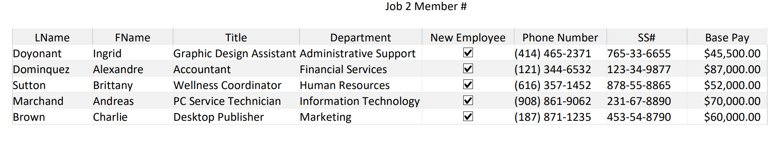
JOB 2A: Database Table

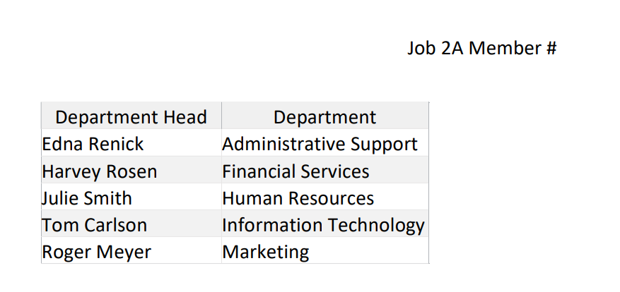

JOB 2B: Relationship Report

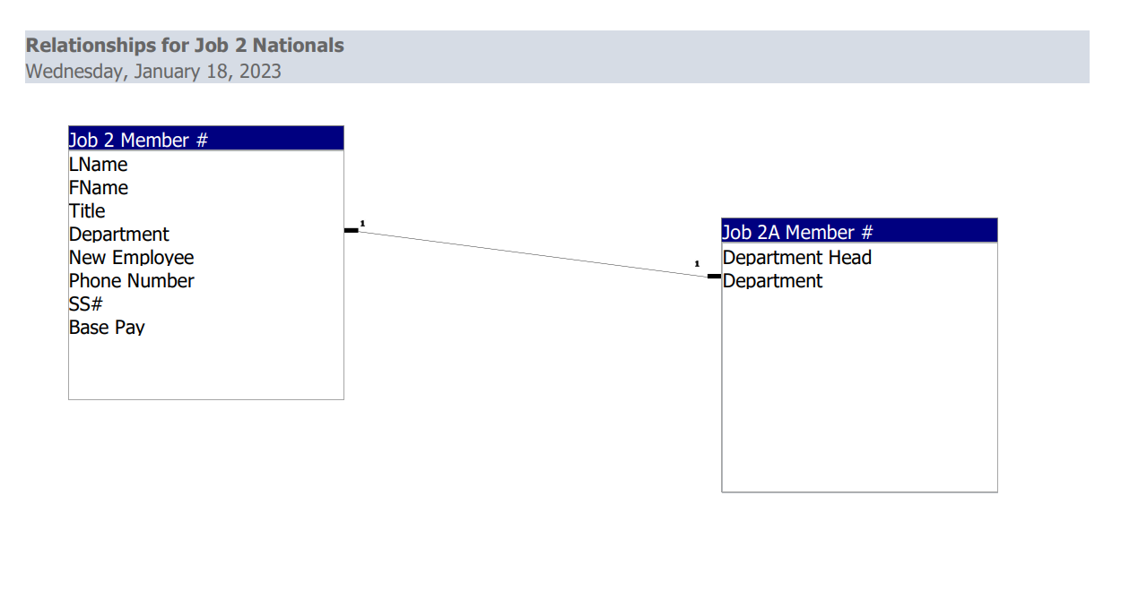
JOB 2C: Query

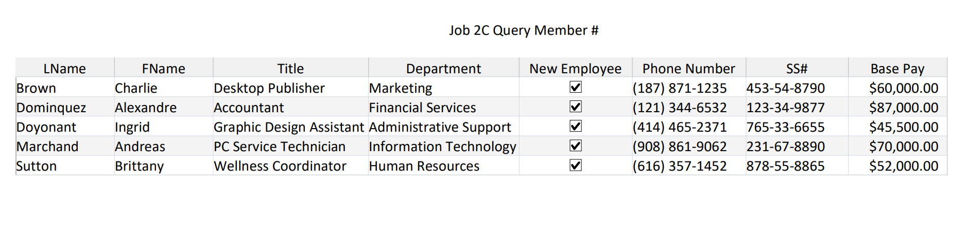
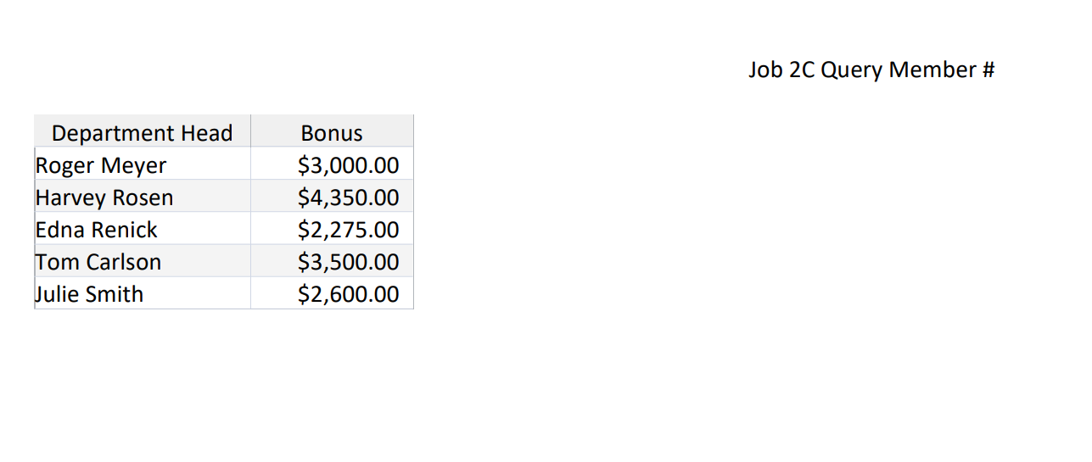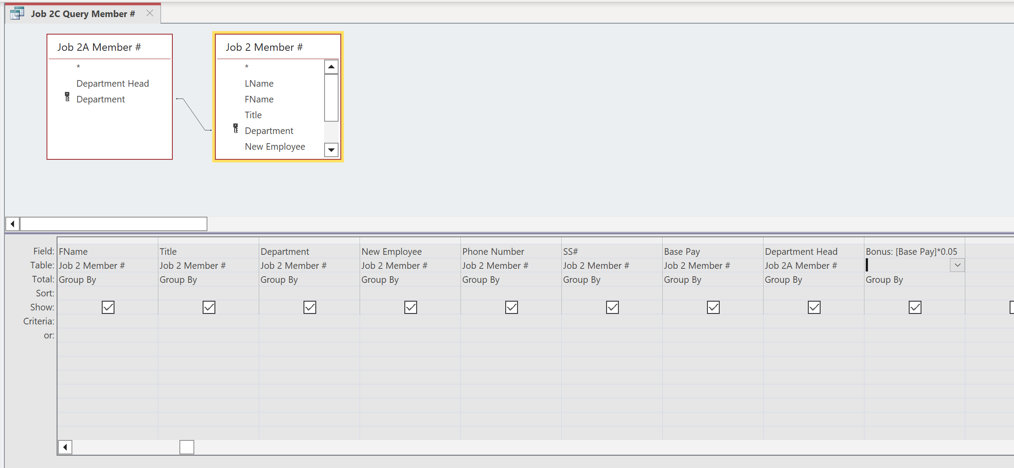

JOB 3: Spreadsheet
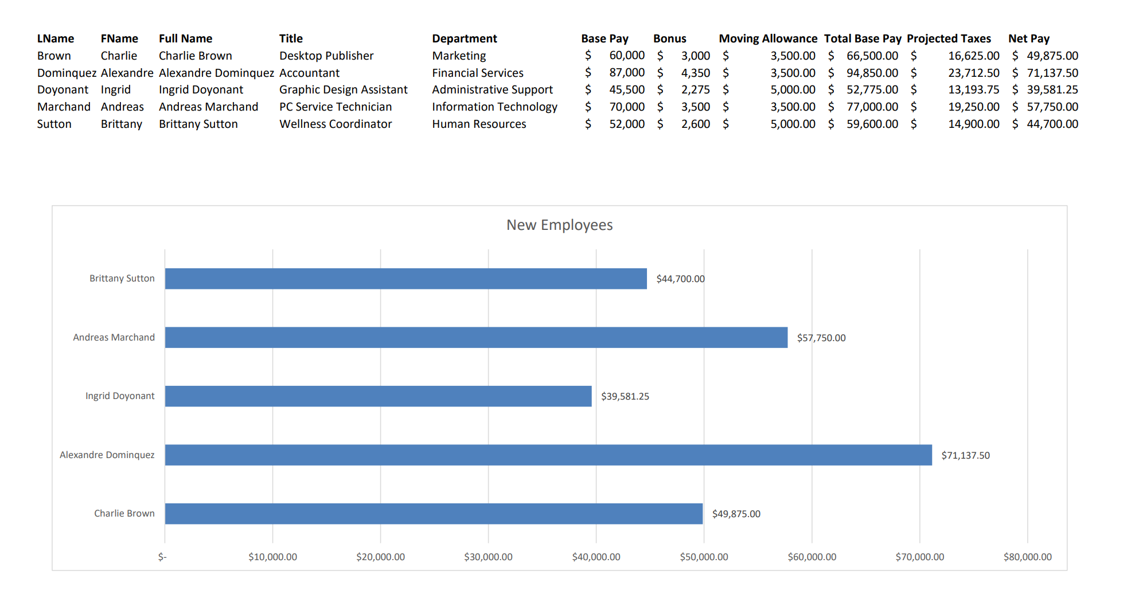
JOB 3: Spreadsheet w/formulas
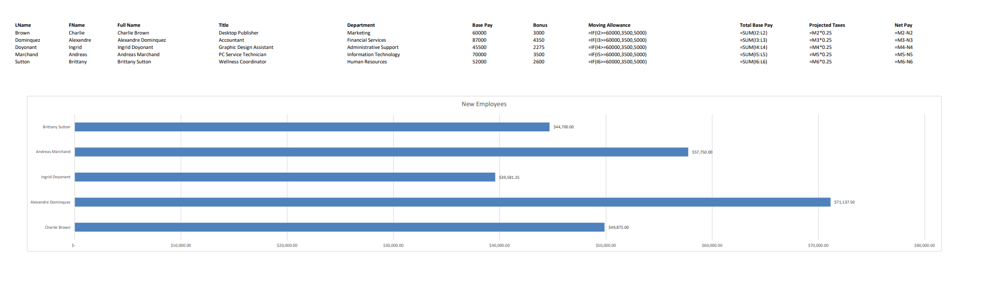

JOB 4: Memorandum. [Note to Grader: 1” top margin, 1” side margins. Refer to the Style & Reference Manual for formatting guidelines.]

MEMORANDUM

TO: «Full_Name»

FROM: Julie Smith

CC: Edna Renick

DATE: use current date

SUBJECT: Bonus and Moving Allowance

Congratulations on your employment with our company! Your interview skills, qualifications, experience, and education set you apart from the pool of candidates.

Please look at the following information we discussed when you accepted your position. A reminder that your moving allowance is based on your base pay. For $60,000 and under you will receive $3,500, over $60,000 the allowance will be $5,000. This will be a separate lump sum deposit from your payroll, paid to you as a benefit upon hire even if you do not need to relocate.

Base Pay «Base_Pay»
Bonus «Bonus»
Moving Allowance «Moving_Allowance»

Please reach out to me if you have any questions or if you see discrepancies with the above information. I can be reached at extension 3426.

#######

MEMORANDUM

TO: Alexandre Dominquez

FROM: Julie Smith

CC: Edna Renick

DATE: use current date

SUBJECT: Bonus and Moving Allowance

Congratulations on your employment with our company! Your interview skills, qualifications, experience, and education set you apart from the pool of candidates.

Please look at the following information we discussed when you accepted your position. A reminder that your moving allowance is based on your base pay. For $60,000 and under you will receive $3,500, over $60,000 the allowance will be $5,000. This will be a separate lump sum deposit from your payroll, paid to you as a benefit upon hire even if you do not need to relocate.

Base Pay 87000
Bonus 4350
Moving Allowance 3500

Please reach out to me if you have any questions or if you see discrepancies with the above information. I can be reached at extension 3426.

#######

